**Angular project setup**

Setting up a new angular project from scratch is a tedious and time consuming process. However, Angular CLI makes it super fast and easy. With angular development, we write same boiler plate code to create components, pipes, services, directives etc. Manually creating these consumes lot of time. Angular CLI can generate these with lightning speed while still following Angular's best practices and conventions. So basic knowledge of Angular CLI is very helpful.

The prerequisites for this course are basic knowledge of **Bootstrap**, **Angular CLI** and **Angular 4**. If you are new to these please check out our courses using the links below.

1. [Angular CLI](http://csharp-video-tutorials.blogspot.com/2017/10/angular-cli-tutorial-for-beginners.html)
2. [Angular 4](http://csharp-video-tutorials.blogspot.com/2017/06/angular-2-tutorial-for-beginners_12.html)
3. [Bootstrap](http://csharp-video-tutorials.blogspot.com/2016/05/bootstrap-tutorial-for-beginners.html)

**Installing the tools required**   
  
**Node :** Install the latest version of node. Here is the link to download and install the latest version  
<https://nodejs.org/en/download/>  
  
As of this recording the latest version is 8.9.2 which is what I have installed. Run windows command prompt as an administrator and execute the following command to verify the version of node installed on your machine.  
node -v  
  
**Angular CLI :** Install the latest version of Angular CLI by executing the following command from the windows command prompt.   
npm install -g @angular/cli  
  
As of this recording, the latest version is 1.6.0 which is what I have installed on my machine. To verify the version of Angular CLI installed on your machine execute the following command.  
ng -v  
  
Another question that you might have is, which version of Angular are we using with this course. As of this recording, the latest version is Angular 5, which is what we will be using.   
  
After you have the latest version of Node and Angular CLI installed, launch windows command prompt as an administrator and execute the following command. This creates a new AngularProject with name AngularCrud. We do not want test files to be generated for the root component AppComponent, so we have set "skip-tests" option to true. We will discuss unit testing components in a later video.  
ng new AngularCrud --skip-tests true   
  
This command creates a brand new Angular Project with name AngularCrud. In windows command prompt change to the directory that contains your angular project using the following command.  
cd AngularCrud  
  
Once you are in the project directory, execute the following command to open the project with Visual Studio Code, by executing the following command from the windows command prompt   
code .  
  
Once you have the Angular project opened in Visual Studio Code, open **package.json** file and notice that we are using Angular 5.   
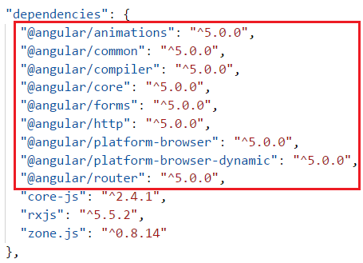  
  
We will be using Bootstrap for styles in our application. So install Bootstrap by executing the following command from the command prompt.  
npm install bootstrap@3 --save  
  
Once Bootstrap is installed, open .angular-cli.json file and specify the path to the Bootstrap stylesheet (bootstrap.min.css) in the styles property as shown below.

"styles": [

  "../node_modules/bootstrap/dist/css/bootstrap.min.css",

  "styles.css"

]